
µFalcon-RX
  - Compact Edge xHaul PTP Switch & Clock

Product Overview  The µFalcon-RX is an essential element in delivering on the promise of 5G. Through high capacity, low latency transport and high precision synchronization, the µFalcon-RX enables 5G RAN operation at its optimal capacity, on both telecom and enterprise environments.  The µFalcon-RX combines the best of breed of the Transport and Timing worlds, in a single powerful package. Both elements are critical for 5G fronthaul deployments, along with support for the latest O-RAN architectures and recommendations.  The µFalcon-RX’s Timing toolbox includes a complete set of capabilities, including GNSS based PTP GM/BC/TC/OC (sub nanosecond accuracy, Class C/D performance), along with robust SyncE and other sync interfaces. The system’s timing is orchestrated via Fibrolan’s user friendly SyncCenter.  The µFalcon-RX series is equipped with a total of 6xSFP+ and 2xSFP28 ports, with configurable port setup for up to 110Gbps Full Duplex. All ports can operate at full wire speed, at any packet size (including Jumbo frames).  The µFalcon-RX offers advanced Quality of Service (QoS) features including classification and mapping based on layer 1 through layer 4 attributes, port and queue policing and shaping, with highly flexible scheduling schemes.  Support for Time Sensitive Networks (TSN) makes the µFalcon-RX an even greater fit for fronthaul, as well as industrial environments (Industry 4.0, IIoT), where 5G infrastructure serves the automation of factories.  The µFalcon-RX fully supports O-RAN LLS-C1 through C4 configuration including the | - LTE/5G xHaul Transport and Timing switch  - Integrated PTP Grandmaster  - Compatible with O-RAN architectures  - High capacity, low latency  - Extensive Sync and Timing with SyncE and PTP (PTRC/GM, BC, TC)  - Sub nanosecond timestamping, Class C/D performance  - Time Sensitive Networking support  - Based on 4th generation Falcon architecture  - Advanced QoS and service level traffic management  - Advanced OAM and management capabilities  - Multiple protection mechanisms for link, path, and ring service resilience  - Compact, low power  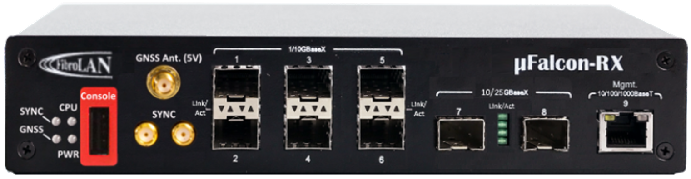  forwarding of C/U-plane eCPRI packets and S/M planes for management and synchronization.  Multiple protection schemes help cover any deployment topology (linear, star, ring) and deliver the reliability required for critical infrastructure such as 5G. In addition, L3 forwarding is supported (static; dynamic routing in future SW releases).  The system implements effective OAM tools, for monitoring, alarming, analysis and troubleshooting of the system and the forwarding plane as well as the synchronization plane.  The µFalcon-RX is housed in a highly compact, half-19”, 1U chassis (150mm deep only) and has an integrated internal, dual feed DC power supply.

Technical Specifications
Interfaces & Indicators
Ethernet:  - 6 x 1/2.5/10G (SFP+)  - 2 x 1/2.5/10/25G (SFP28)  - Supported SFP/SFP+: MM, SM, SFS, xWDM, Copper  Sync & Timing:  - All optical ports support PTP, SyncE and NTP  - GNSS antenna in (SMA, active, 5VDC)  - 2 x external 1PPS/10MHz (SMA) | Management (OOB):  - 1 x 10/100/1000BaseT (RJ45)  - 1 x USB (console)  LEDs  - Link/Activity (per port)  - Sync  - GNSS  - CPU  - Power
Architecture & Forwarding
Hybrid (ASIC-FPGA) HW architecture  L2 forwarding (802.1D MAC bridging)  Flow-based forwarding  Performance: wire-speed, on all ports, all frame sizes  Switching fabric: 220Gbps (110Gbps/FDX), non-blocking  MTU: 10K bytes  MAC table: 32K addresses  VLANs: 4K concurrent  Provider bridging: 802.1ad (Q-in-Q) | Private VLANS  L1-L4 ACLs  Multicast:  - IGMPv3 snooping  - MLD snooping  - Up to 8K MC groups  Layer 3:  - Static routes  - IPv4/IPv6  - DHCP (client, server, relay)  Time Sensitive Networking
Management
Interfaces:  - CLI: Console, Telnet, SSH  - SNMP: v1/v2c/v3, extensive MIBs  - Web: HTTP/HTTPS  - Management VLAN  - IPv6 management  Authentication:  - RADIUS, TACACS+  - Multiple local users  - User access levels (15)  - Management ACLs  - 802.1x (port/MAC based)  DHCP client, relay, server, snooping  Link discovery: LLDP, LLDP-MED, CDP ware | CPU sub-system:  - Dual-core, @1GHz, ARM  - 1GB DDR, 4GB flash memory  Operations:  - Remote System Update (TFTP or Web)  - Configuration upload/download (TFTP or Web)  - Text based config files  Alarms:  - SNMP traps  - Syslog (internal and remote server)  - CLI events  Remote temperature reading & alarm  Per port and queue detailed statistics  RMON
OAM & Diagnostics
IEEE802.3ah Link OAM  IEEE802.1ag CFM  Ping (IPv4/v6)  Traceroute (Ipv4/v6) | Throughput metering  SFP diagnostics (SFF-8472)  Traffic mirroring and remote mirroring  sFlow
Protection
Link aggregation: static or LACP  Loop protection | Linear protection: G.8031  Ring protection: G.8032v2  Spanning tree: STP, RSTP, MSTP

PTP/IEEE1588v2
Functions:  - Grandmaster (PRTC-A)  - Boundary Clock (Class C/D)  - Ordinary Clock (M/S)  - Transparent Clock (Class C/D)  Profiles supported:  - Telecom Frequency (G.8265.1)  - Telecom Phase (G.8275.1, G.8275.2)  - Default (IEEE1588v2)  - 802.1AS  - Custom |  |  |  | Modes supported:  - 1 and 2 step  - L2 Multicast  - L3/UDP Unicast/Multicast  - Mixed transport modes  - E2E and P2P delay  - VLAN tagging  Slave capacity:  - Up to 256 Unicast @ full packet rate  - Support for max packet rates for:  Announce, Sync and Del.Req/Del.Resp messages  HW timestamping: <1nsec resolution
Other Timing Services/Features
Synchronous Ethernet (SyncE):  - G.8261, G.8262  - ESMC (G.8264)  GNSS:  - 32 channels  - Multi-constellation :  GPS, GLONASS, Galileo, Beidou, QZSS  Support O-RAN configurations LLS-C1/C2/C3/C4 |  |  |  | SyncCenter  NTP  - Client  - Server  External Sync:  - Input/output  - 1PPS/10MHz  Local clock:  - Built-in Stratum 3E clock
Holdover Performance
 | Oscillator \ T.Err | 200nsec | 400nsec |  | 1usec | 1.5usec | 5usec | -
 | HQ-OCXO | 1.5 hours | 3 hours |  | 5 hours | 8 hours | 22 hours
Note: the above are typical values, assuming the system was locked to GNSS for at least 72 hours, at a constant temperature and the system was powered for at least 30 days.
Quality of Service
Classification based on L1-L4 information  Ingress policing per port/queue  Hierarchical shaping and scheduling  Priority based flow control (802.1Qbb)  Scheduling: Strict, DWRR, hybrid |  |  |  | 4 drop precedence levels  WRED and tail drop for CA  P-bit and DSCP remarking  Storm control: UC, MC, BC  QoS Control Lists
Power & Environmental
Power Supply:  - Internal power supply: 20-60VDC, dual feed  - AC adapter option (FPA40)  Power consumption:  - Maximum: <30W; typical: <25W |  |  |  | Operating temperature:  - Standard: -10°C ÷ +50°C (14°F ÷ 122°F)  - Extended: -40°C ÷ +65°C (-40°F ÷ 149°F) (optional)  Storage temperature: -40°C ÷ +80°C (-40°F ÷ 176°F)  Humidity: 10-90%, non-condensing
Physical
Dimensions (HxWxD):  - 44x221x150mm (1.73x8.70x5.90 inch)  Mounting: Desktop, Rack, Wall  Weight: ~0.8Kg (1.76 lb) |  |  |  | Accessories:  - Power cable  - USB cable (console)  - Rack mounting kit (optional)
Regulatory & Compliance
Safety: IEC EN60950-1  CE  RoHS |  |  |  | EMC:  - FCC CFR 47 part 15, subpart B, Class A  - EN 300 386 V1.3.3: 05

Typical Application: Private LTE/5G/CBRS
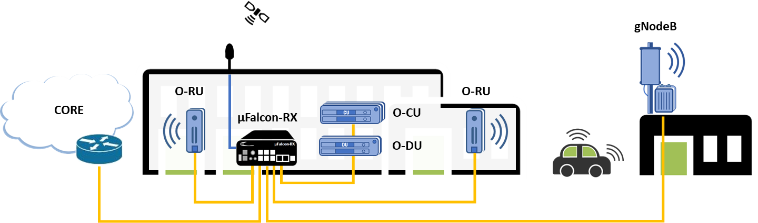
Ordering Information
Model | P/N | Description
µFalcon-RX/206/G/D | 7162 | Timing Aware Compact Edge xHaul Switch, 6x10G (SFP+), 2x25G (SFP28) ports, Advanced Timing spec  w/ GNSS Rx, internal DC (20-60VDC) dual feed power supply, and TNC to SMA GNSS cable adapter
FPA40 | 7108 | AC (100-240V) to DC (48V) power adapter, 40W
Specifications are subject to change w/o prior notice


It’s About Time
Intl. Headquarters  Fibrolan Ltd.  Tel: +972-4-959-1717  Fax: +972-4-959-1718  info@fibrolan.com  www.fibrolan.com | North America  Fibrolan Inc.  Tel: +1-201-843-1626  Fax: +1-201-843-1628  info.us@fibrolan.com  www.fibrolan.com | Central-Eastern Europe  Fibrolan CEE GmbH.  Tel: +43 2253 21188-0  Fax: +43 2253 21188-99  Info.cee@fibrolan.com  www.fibrolan.com
Revision: uFalcon-RX_DS_2026-09-27_v1-9d
© Fibrolan 2026. All Rights Reserved
‹#›

